# Research question

* How does the difference in size between ecosystem patches influence meta-ecosystems dynamics in the face of perturbations?

# Hp

* Larger patch will have higher and wider abundance-pyramid
* Larger patch will have higher biomass density
* Effect of detritus flow will be stronger when coming from a larger patch

# Design

* 7 ecosystem conditions (from the top to the bottom: small ecosystem, medium ecosystem, large ecosystem, connected small ecosystems, connected medium ecosystems, connected large ecosystems, connected small and large ecosystems)
* 2 perturbation intensities (from the left to the right: small perturbation and large perturbation)

*x5 = five replicates, small perturbation =* 5.25 ml (70% of small patch volume), 6.75 ml (90% of small patch volume)

# Cultures

**Mixed cultures (ecosystem)**

* *Total number*
  + Total number of cultures =110
* *Culture containers* 
  + 50 ml falcon tubes
* *Patch volumes* 
  + small = 7.5 ml
  + medium = 22.5 ml
  + large = 37.5 ml
* *Composition*
  + Ble, Cep, Col, Eug, Eup, Lox, Pau, Pca, Spi, Spi te, Tet.
  + All in equal volume.

**High-densities monocultures used to assemble mixed cultures**

* 3x 500 ml flasks, each containing 200 ml culture composed of
  + 10% protists (20 ml) (*if species abundances are low, we will have to increase the percentage of protist volume from 10% to 20-30-50%, according to how low they are. Bacterial solution and filtered PPM will be reduced in volume accordingly.*)
  + 5% bacterial solution (10 ml)
  + 85% filtered PPM (170 ml) (*or lower if the percentage of protists is higher*)
* It is really important that Eug starts at high concentrations
* It is important to have the large species (Spi, Spi te, Pca, Pau) in high densities so that when pipetting we are not missing them

**Assembly of mixed cultures**

* Selection of high-density monocultures (monocultures that grew to actual high density will be used)
* Mix of high-density monocultures in a large mixing bottle
* Creation of a large bottle with all the selected high-density monocultures (so we have to pipette only 1/mixed culture). All species will be assembled to the same concentration (1/11 of the total volume).
* Don’t pour the bottom of the cultures (it is really dense)
* Add into the best culture a little bit of the second-best culture (around 20 ml) to have extra volume

# Videos

**Eppendorf tubes:** yes – cultures are transferred into Eppendorf tubes in the climate chamber so that they don’t have to come up.

**Videos**

125 frames/video. For the rest, see protocol 18 from the Altermatt lab Wiki Page.

**Training of BEMOVI species identification algorithm**

* 11x dilution 100 ml monocultures created from high-density monocultures on t0 (1 culture/species)
* Videos/species = TBA (until reaching 100 individuals/species, using eye counting)

# Resource exchange

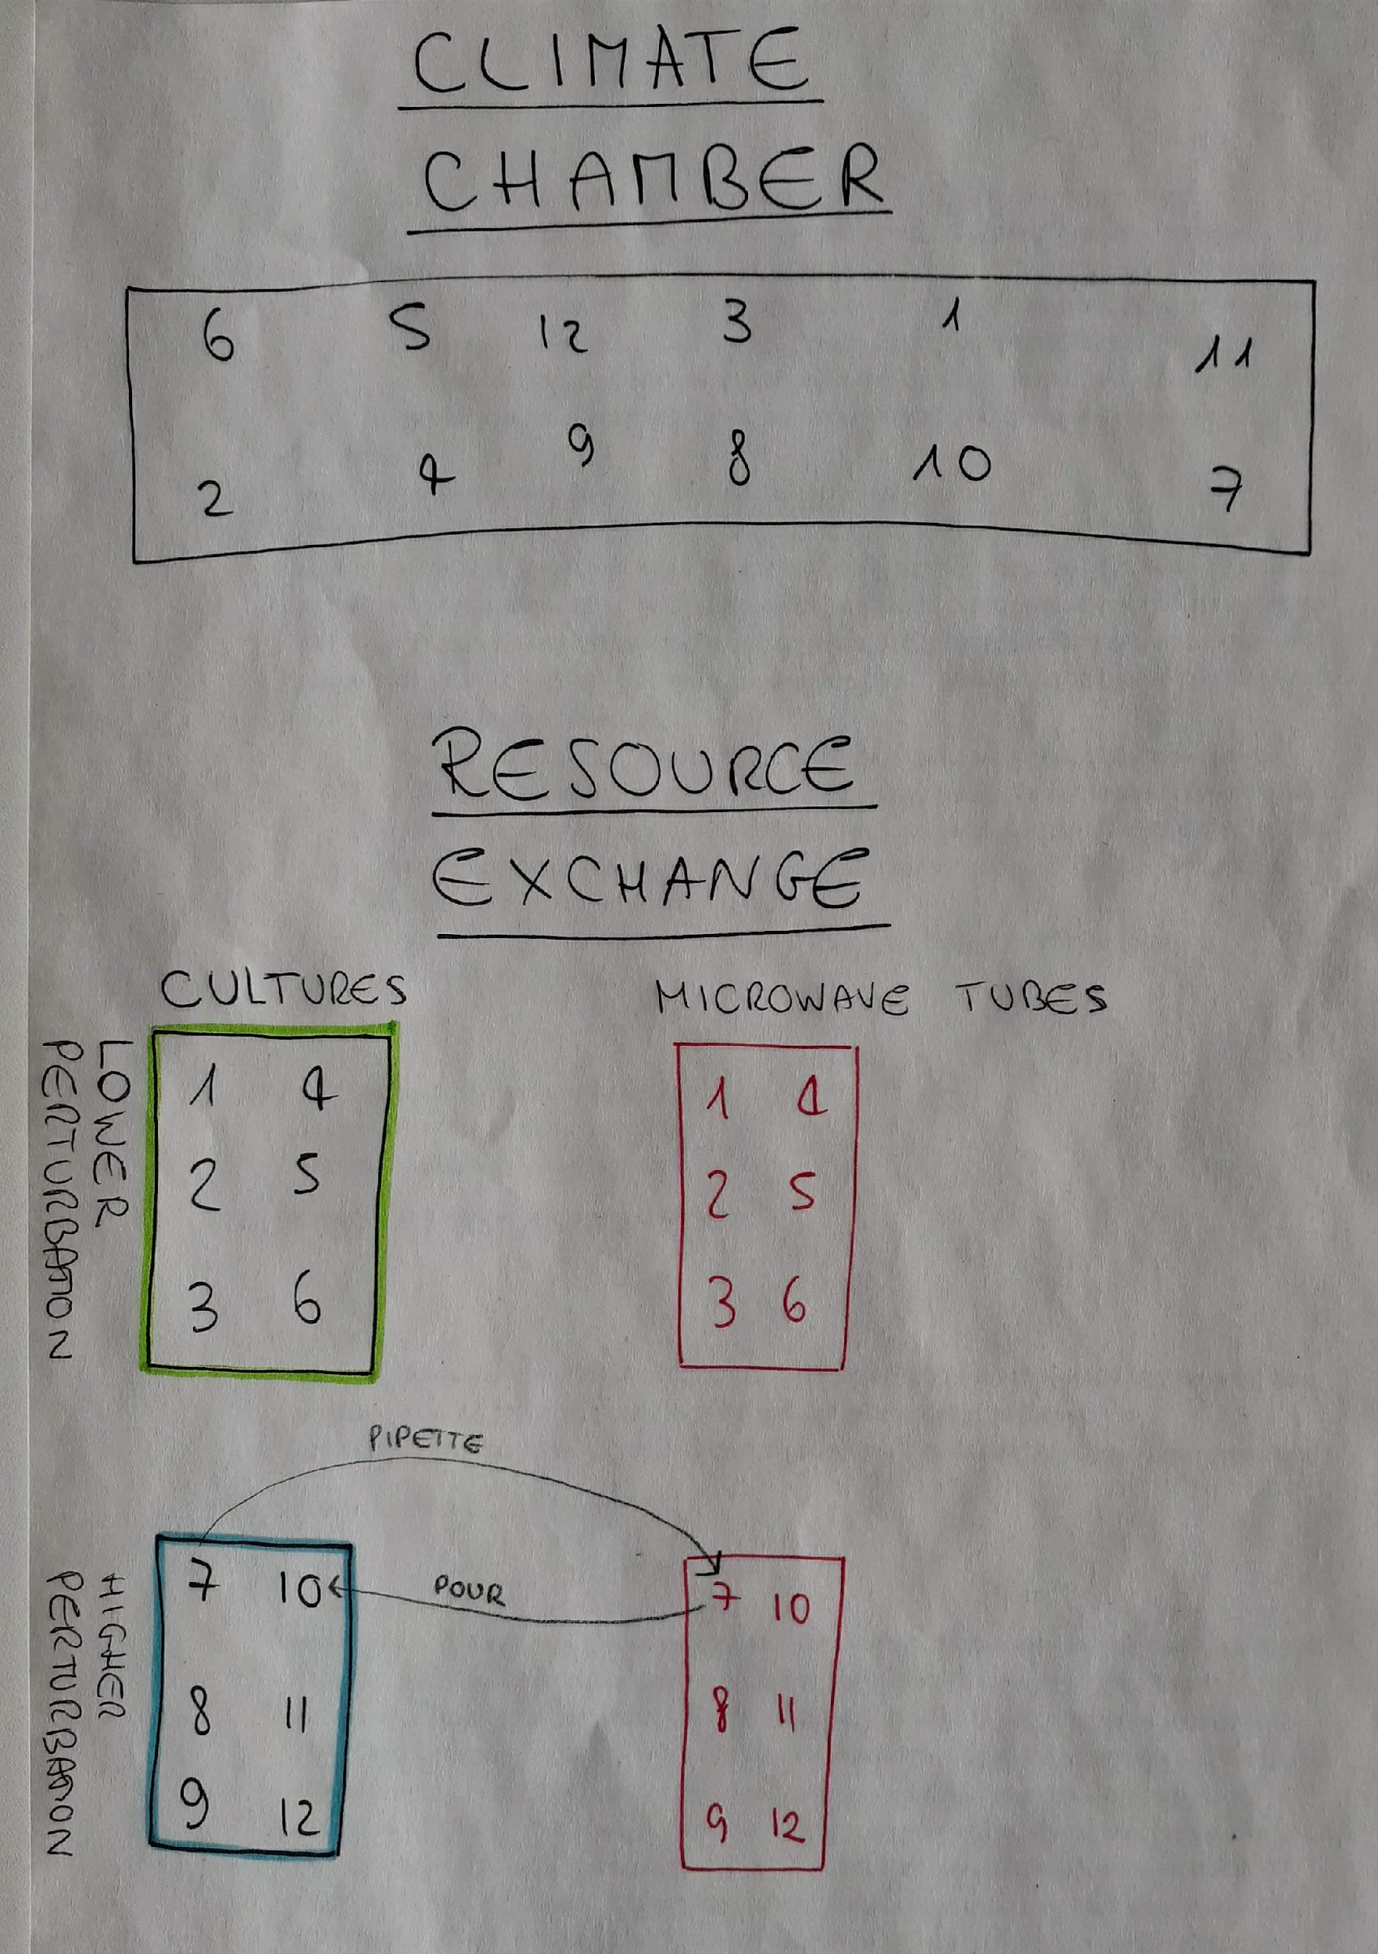

The cultures are randomised in the climate chamber but when we bring them upstairs to exchange resources. For each culture rack with 50 ml falcon tubes, there is a rack where we put the 15 ml falcon tubes we use for microwaving. Having tubes of different sizes allows us to distinguish between cultures and microwaving tubes. The racks are separated into cultures with low perturbation (green) and high perturbation (blue).

Labels. The racks will be divided into green racks (low perturbation) and blue racks (high perturbation). Each rack will be labelled as you can see at the bottom of the figure. Falcon tubes will be labelled on the top part of the figure. Their number will appear on the tube and on the tube cap. Cultures will be labelled also with a protist picture, and microwaving tubes will be labelled with a three waves label.

* 10 ml micropipette tips will be first thrown into a larger Becker, then into a large box filled with deionised water. The tips will be left dry overnight, then autoclave the day after.
* Racks
* Racks will have 5 replicate blocks, therefore I will need 6 racks for holding the 50 ml falcon tubes and 6 racks for holding the 15 ml falcon tubes also
* Cultures are brought upstairs in batches

**Refilling of cultures**

* Addition of 0.82 ml of deionised water to counteract microwaving
* Addition of 175 ml of PPM to counteract the sampling for video analysis
* Both mixed in a large jar and added right before the resource exchange

**Labels**

* The labels should be as small as possible so that the autotrophic species get as much light as possible.
* Labelling also of the stereo foams

**BEMOVI**

* The video description file contains the videos in the randomised order

# Timeline

|  |  |  |
| --- | --- | --- |
| **Day (t)** | **Date (potentially)** | **Task** |
| -21 | We 23.3 | Make non-filtered PPM [*for increasing culture collection @ t-14*] |
| -18 | Sa 26.3 | Increase culture collection (create three new 100 ml cultures/protist) |
| -17 to -11 | Fr 25.3 –  Th 31.3 | Gather and autoclave material |
| -10 | Fr 1.4 | Make and autoclave filtered PPM + autoclave deionised water *[for high-density monocultures @ t-7]* |
| -8 | Su 3.4 | Create bacterial solutions from bacterial mix (*Bacillus subtilis*, *Bacillus brevis*, *Serratia fonticuli)* [*for high density monoculture @ t-7*] |
| -7 | Mo 4.4 | Create high-density monocultures |
| -4 | Th 7.4 | Check high-density monocultures (replace ones not growing well enough) |
| -2 | Mo 11.4 | Check experiment design in the lab w/ Florian (8 AM) |
| -1 | Tu 12.4 | Film monocultures for training |
| 0 | We 13.4 | Assembly of mixed cultures and training monocultures Take videos (experiment + training monocultures) |
| 4 to 28* | Su 17.4 –  We 11.5 | Day I: Take videos (experiment + training monocultures)  Day II: Exchange resources in 15 ml falcon tubes to distinguish them from the cultures  Day III and IV: Nothing to do |

* Starting from day 4, repeat until day 28

Lab work

* Take photos of the disposition of the Eppendorf tubes

Print

* Print the disposition of the cultures on the foam board (randomised sequence)

Informatics

* Write video description files